Lab Sheet: 3
Objectives

- To understand the use of COMMIT and ROLLBACK commands in transaction control.
- To use ORDER BY and GROUP BY clauses in SQL queries.
- To understand DCL commands (GRANT, REVOKE) and the use of SAVEPOINT.
- To understand and implement JOIN operations in SQL.

Instructions

Open your preferred Database Management System (DBMS) tool.

- Create the required tables: TEACHER, SALES, DEPARTMENTS, and EMPLOYEES.
- Insert suitable records into each table.
- Execute the SQL commands for transaction control, privilege control, grouping, sorting, and joins.
- Observe the output after each operation such as ROLLBACK, COMMIT, SAVEPOINT, GRANT, and REVOKE.
DDL Questions (Data Definition Language)
1. Create the TEACHER table with the following attributes:
(Name, DeptNo, Date_of_Joining, DeptName, Location, Salary).
CREATE TABLE TEACHER (
TeacherID INT PRIMARY KEY AUTO_INCREMENT,
Name VARCHAR(50) NOT NULL,
DeptNo INT,
Date_of_Joining DATE,
DeptName VARCHAR(50),
Location VARCHAR(50),
Salary DECIMAL(10, 2)
);
2. Create the SALES table with the following attributes:
(Sales_No, Salesname, Branch, Salesamount, DOB).
CREATE TABLE SALES (
Sales_No INT PRIMARY KEY,
Salesname VARCHAR(50),
Branch VARCHAR(50),
Salesamount DECIMAL(12, 2),
DOB DATE
);
3. Create the DEPARTMENTS table with the following attributes:
(dept_no, dept_name, dept_location).
CREATE TABLE DEPARTMENTS (
dept_no INT PRIMARY KEY,
dept_name VARCHAR(50) NOT NULL,
dept_location VARCHAR(50)
);
4. Create the EMPLOYEES table with the following attributes:
(emp_id, emp_name, emp_salary, dept_no).
CREATE TABLE EMPLOYEES (
emp_id INT PRIMARY KEY,
emp_name VARCHAR(50) NOT NULL,
emp_salary DECIMAL(10, 2),
dept_no INT,
FOREIGN KEY (dept_no) REFERENCES DEPARTMENTS(dept_no)
);

DML Questions (Data Manipulation Language)
From TEACHER Table
1. Insert five records into the TEACHER table.
INSERT INTO TEACHER (Name, DeptNo, Date_of_Joining, DeptName, Location, Salary) VALUES
('Dr. Sharma', 10, '2020-01-15', 'Mathematics', 'Block A', 60000),
('Prof. Gupta', 20, '2019-03-22', 'Commerce', 'Block B', 55000),
('Mr. Khan', 10, '2021-08-10', 'Mathematics', 'Block A', 50000),
('Ms. Iyer', 20, '2018-11-05', 'Commerce', 'Block B', 58000),
('Dr. Reddy', 30, '2022-05-12', 'Science', 'Block C', 65000);
2. Give an increment of 25% salary to teachers working in the Mathematics department.
UPDATE TEACHER
SET Salary = Salary * 1.25
WHERE DeptName = 'Mathematics';
3. Give an increment of 15% salary to teachers working in the Commerce department.
UPDATE TEACHER
SET Salary = Salary * 1.15
WHERE DeptName = 'Commerce';

From SALES Table
1. Insert five records into the SALES table.
INSERT INTO SALES (Sales_No, Salesname, Branch, Salesamount, DOB) VALUES
(101, 'Rahul', 'North', 50000, '1995-12-21'),
(102, 'Sonia', 'East', 75000, '1992-05-14'),
(103, 'Amit', 'North', 40000, '1998-12-09'),
(104, 'Vikram', 'West', 60000, '1994-01-25'),
(105, 'Anjali', 'East', 80000, '1993-12-30');
2. Calculate the total sales amount in each branch.
SELECT Branch, SUM(Salesamount) AS Total_Sales
FROM SALES
GROUP BY Branch;
3. Calculate the average sales amount in each branch.
SELECT Branch, AVG(Salesamount) AS Avg_Sales
FROM SALES
GROUP BY Branch;
4. Display the Salesname and DOB of salesmen born in the month of December with date format like 21-Dec-09.
SELECT Salesname, DATE_FORMAT(DOB, '%d-%b-%y') AS DOB
FROM SALES
WHERE MONTH(DOB) = 12;
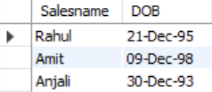
5. Display the Salesname and DOB of salesmen in alphabetical order of the month.
SELECT Salesname, DOB
FROM SALES
ORDER BY DATE_FORMAT(DOB, '%M');
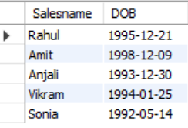
From JOIN Operations
1. Display employee details and department details where the department numbers are the same in both tables.
SELECT E.*, D.* FROM EMPLOYEES E
INNER JOIN DEPARTMENTS D ON E.dept_no = D.dept_no;
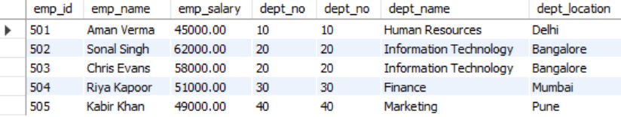
2. Display the employee name and department name using a LEFT OUTER JOIN.
SELECT E.emp_name, D.dept_name
FROM EMPLOYEES E
LEFT JOIN DEPARTMENTS D ON E.dept_no = D.dept_no;
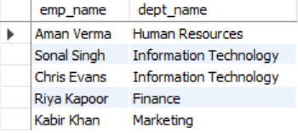
3. Display the employee name and department name using a RIGHT OUTER JOIN.
SELECT E.emp_name, D.dept_name
FROM EMPLOYEES E
RIGHT JOIN DEPARTMENTS D ON E.dept_no = D.dept_no;
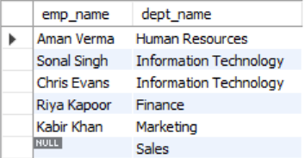
4. Display the details of employees who draw a salary greater than the average salary.
SELECT * FROM EMPLOYEES
WHERE emp_salary > (SELECT AVG(emp_salary) FROM EMPLOYEES);
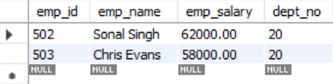

TCL Questions (Transaction Control Language)

1. Perform the ROLLBACK command on the TEACHER table.
UPDATE TEACHER SET Salary = Salary * 5;
ROLLBACK TO SAVEPOINT SP1;
ROLLBACK;
2. Perform the COMMIT command on the TEACHER table.
COMMIT;
3. Write a query to implement a SAVEPOINT.
START TRANSACTION;
INSERT INTO TEACHER (Name, DeptName, Salary)
VALUES ('New Instructor', 'Physics', 45000);
SAVEPOINT SP1;
DCL Questions (Data Control Language)
1. Write a query to grant all privileges on the EMPLOYEES table to DEPARTMENTS.
GRANT ALL PRIVILEGES ON EMPLOYEES TO 'DEPARTMENTS'@'localhost';
2. Write a query to grant selected privileges on the EMPLOYEES table to DEPARTMENTS.
GRANT SELECT, UPDATE ON EMPLOYEES TO 'DEPARTMENTS'@'localhost';
3. Write a query to revoke all privileges on the EMPLOYEES table from DEPARTMENTS.
REVOKE ALL PRIVILEGES ON EMPLOYEES FROM 'DEPARTMENTS'@'localhost';
4. Write a query to revoke selected privileges on the EMPLOYEES table from DEPARTMENTS.
REVOKE UPDATE ON EMPLOYEES FROM 'DEPARTMENTS'@'localhost';

